**DDL:**

CREATE TABLE lgs

(

storeID CHAR(15) CONSTRAINT PK_storeID PRIMARY KEY CONSTRAINT lgs_nn_storeID NOT NULL,

storeName VARCHAR2(30)CONSTRAINT lgs_nn_storeName NOT NULL,

phoneNumber CHAR(11) CONSTRAINT lgs_nn_phoneNumber NOT NULL,

addressStreet VARCHAR2(30) CONSTRAINT lgs_nn_addressStreet NOT NULL,

addressCity VARCHAR2(30) CONSTRAINT lgs_nn_addressCity NOT NULL,

addressState VARCHAR2(30) CONSTRAINT lgs_nn_addressState NOT NULL,

addressZipCode CHAR(5) CONSTRAINT lgs_nn_addressZipCode NOT NULL

)

CREATE TABLE Product

(

SKUNumber CHAR(30) CONSTRAINT PK_SKUNumber PRIMARY KEY CONSTRAINT Product_nn_SKUNumber NOT NULL,

quantity NUMBER(4) CONSTRAINT Product_nn_quantity NOT NULL,

price NUMBER(6,2) CONSTRAINT Product_nn_price NOT NULL,

isBook NUMBER(1) CONSTRAINT Product_nn_isBook NOT NULL CONSTRAINT Product_ck_isBook CHECK (isBook IN (1,0)),

title VARCHAR2(50),

author VARCHAR2(100),

edition VARCHAR2(4),

isTrinket NUMBER(1) CONSTRAINT Product_nn_isTrinket NOT NULL CONSTRAINT Product_ck_isTrinket CHECK (isTrinket IN (1,0)),

trinketName VARCHAR2(100),

trinketSize NUMBER(4,2),

CONSTRAINT chk_book CHECK ((isTrinket = '1' AND isBook = '0') OR (isTrinket = '0' AND isBook = '1'))

)

CREATE TABLE CommunityMember

(

memberID CHAR(20) CONSTRAINT PK_memberID PRIMARY KEY CONSTRAINT CommunityMember_nn_memberID NOT NULL,

firstName VARCHAR2(50) CONSTRAINT CommunityMember_nn_firstName NOT NULL,

lastName VARCHAR2(50) CONSTRAINT CommunityMember_nn_lastName NOT NULL,

phoneNumber CHAR(11) CONSTRAINT CommunityMember_nn_phoneNumber NOT NULL,

addressStreet VARCHAR2(30) CONSTRAINT CommunityMember_nn_addressStreet NOT NULL,

addressCity VARCHAR2(30) CONSTRAINT CommunityMember_nn_addressCity NOT NULL,

addressState VARCHAR2(30)CONSTRAINT CommunityMember_nn_addressState NOT NULL,

addressZipCode VARCHAR2(5) CONSTRAINT CommunityMember_nn_addressZipCode NOT NULL

)

CREATE TABLE SponsorshipCompany

(

companyID CHAR(25) CONSTRAINT PK_companyID PRIMARY KEY CONSTRAINT SponsorshipCompany_nn_companyID NOT NULL,

companyName VARCHAR2(30) CONSTRAINT SponsorshipCompany_nn_companyName NOT NULL,

phoneNumber CHAR(11) CONSTRAINT SponsorshipCompany_nn_phoneNumber NOT NULL,

emailAddress VARCHAR2(100) CONSTRAINT SponsorshipCompany_nn_emailAddress NOT NULL,

addressStreet VARCHAR2(30) CONSTRAINT SponsorshipCompany_nn_addressStreet NOT NULL,

addressCity VARCHAR2(30) CONSTRAINT SponsorshipCompany_nn_addressCity NOT NULL,

addressState VARCHAR2(30) CONSTRAINT SponsorshipCompany_nn_addressState NOT NULL,

addressZipCode CHAR(5) CONSTRAINT SponsorshipCompany_nn_addressZipCode NOT NULL

)

CREATE TABLE Convention

(

conventionID CHAR(10) CONSTRAINT PK_conventionID PRIMARY KEY CONSTRAINT Convention_nn_conventionID NOT NULL ,

eventName VARCHAR2(100) CONSTRAINT Convention_nn_eventName NOT NULL,

eventDate DATE CONSTRAINT Convention_nn_eventDate NOT NULL,

eventLocation CHAR(15)CONSTRAINT Convention_nn_eventLocation NOT NULL CONSTRAINT Convention_fk_eventLocation REFERENCES lgs(storeID),

sponsor CHAR(25) CONSTRAINT Convention_nn_sponsor NOT NULL CONSTRAINT Convention_fk_sponsor REFERENCES SponsorshipCompany(companyID)

)

CREATE TABLE Registration

(

event CHAR(10)CONSTRAINT Registration_nn_event NOT NULL CONSTRAINT Registration_fk_event REFERENCES Convention(conventionID),

attendee CHAR(20) CONSTRAINT Registration_nn_attendee NOT NULL CONSTRAINT Registration_fk_attendee REFERENCES CommunityMember(memberID),

CONSTRAINT pk_Registration PRIMARY KEY(event, attendee)

)

CREATE TABLE Sale

(

location CHAR(15) CONSTRAINT Sale_nn_location NOT NULL CONSTRAINT Sale_fk_location REFERENCES LGS(storeID),

product CHAR(30) CONSTRAINT PK_product PRIMARY KEY CONSTRAINT Sale_nn_product NOT NULL CONSTRAINT Sale_fk_product REFERENCES Product(SKUNumber),

consumer CHAR(20) CONSTRAINT Sale_nn_consumer NOT NULL CONSTRAINT Sale_fk_consumer REFERENCES CommunityMember(memberID)

)

CREATE TABLE Vendor

(

vendorID CHAR(5) CONSTRAINT PK_vendorID PRIMARY KEY CONSTRAINT Vendor_nn_vendorID NOT NULL,

vendorName VARCHAR2(30) CONSTRAINT Vendor_nn_vendorName NOT NULL,

phoneNumber CHAR(11) CONSTRAINT Vendor_nn_phoneNumber NOT NULL,

merchandiseType VARCHAR2(100) CONSTRAINT Vendor_nn_merchandiseType NOT NULL,

marketPlace CHAR(10)CONSTRAINT Vendor_nn_marketPlace NOT NULL CONSTRAINT Vendor_fk_marketPlace REFERENCES Convention(conventionID)

)

**7. DML:**

INSERT INTO LGS

VALUES ('123456789023456','BigComics', '12674547751', '10 Big Road', 'Calais','Maine','04619');

INSERT INTO LGS

VALUES ('076543216789453','NerdTopia','17147777777','11 Small Stroll Way', 'Santa Ana', 'California', '92707');

INSERT INTO LGS

VALUES ('045362178904563', 'TinyHandsComics', '12024561111', '1100 S Ocean Blvd', 'Palm Beach', 'Florida', '33480');

INSERT INTO CommunityMember

VALUES ('01478520369872768965', 'Bob', 'Saint', '12075556789', '15 Elm St', 'Portland', 'Maine', '04101');

INSERT INTO CommunityMember

VALUES ('96453157789952157890', 'William', 'Waring', '15853216687', '607 S street', 'Philadelphia', 'Pennsylvania', '19147');

INSERT INTO CommunityMember

VALUES ('75369514896317625894', 'Lance', 'Armstrong', '12676632849', '2144 S Birch', 'San Diego', 'California', '22434');

INSERT INTO SponsorshipCompany

VALUES ('9854710236589745698015403', 'BigHandsInc', '18675309555','handsarentsmall@gmail.com','235 Flat Rd', 'Eastport', 'Maine', '04694');

INSERT INTO SponsorshipCompany

VALUES ('9078654321345678905643214', 'SylvanProductions','16677789999','sylvan.products@AOL.com','3164 Eagle Harbor Rd','Machias', 'Maine', '04654');

INSERT INTO SponsorshipCompany

VALUES ('0123698574854698754102365', 'ChannelThunderBall', '13134444789','channelThunder@yahoo.com','235 N Main St','Caribou','Maine', '04736');

INSERT INTO Convention

VALUES ('0462718465', 'ComicalCon', '05-NOV-2021', '076543216789453', '9078654321345678905643214');

INSERT INTO Convention

VALUES ('2056473820', 'TableTops', '17-FEB-2021', '045362178904563', '0123698574854698754102365');

INSERT INTO Convention

VALUES ('0258794561', 'MagikCon', '06-SEP-2021','123456789023456','9854710236589745698015403');

INSERT INTO REGISTRATION

VALUES ('0462718465', '01478520369872768965');

INSERT INTO REGISTRATION

VALUES ('2056473820', '96453157789952157890');

INSERT INTO REGISTRATION

VALUES ('0258794561', '75369514896317625894');

INSERT INTO Product

VALUES ('123456789098789765432345678907', 0020,0029.99,1, 'Players Manual','Bob Hope','5th',0,'','');

INSERT INTO Product

VALUES ('098765432154637289012345678906', 0100,0010.00,0, '','','', 1,'Dice Box',03.50);

INSERT INTO Product

VALUES ('675849301234765478905647321768', 0010,0029.99,1,'Monster Manual','Bob Ross','5th',0,'','');

INSERT INTO Vendor

VALUES('58302','NerdPoria','7776654328','Manuals Dice','0462718465');

INSERT INTO Vendor

VALUES('00035','YugeDragons','58556555755','Figures Paint','0258794561');

INSERT INTO Vendor

VALUES('67893','DnDProps','71426709876','Costumes Props','2056473820');

INSERT INTO Sale

VALUES ('123456789023456', '675849301234765478905647321768','01478520369872768965');

INSERT INTO Sale

VALUES ('076543216789453', '123456789098789765432345678907','96453157789952157890');

INSERT INTO Sale

VALUES ('045362178904563', '098765432154637289012345678906','75369514896317625894');

**8. QUERIES:**

**Description:** This is used to update community members phone numbers. In this instance, it was William Waring. This is useful because people can get new phone numbers and need to update their contact information.

UPDATE CommunityMember

SET phoneNumber = '61055566666'

WHERE phoneNumber = '15853216687';

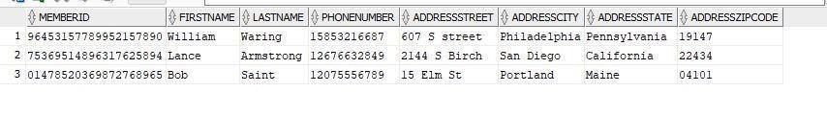

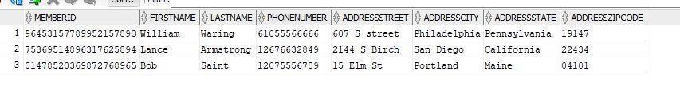

**Description:** This shows the convention ID, Name, and the amount of vendors for each event through a join. Important because the convention can now how many stalls to prepare for vendors in a location.

SELECT c.conventionID, c.eventName, COUNT(v.marketplace) AS Amount_Of_Vendors

FROM convention c JOIN vendor v

ON c.conventionID = v.marketplace

GROUP BY c.conventionID, c.eventName;

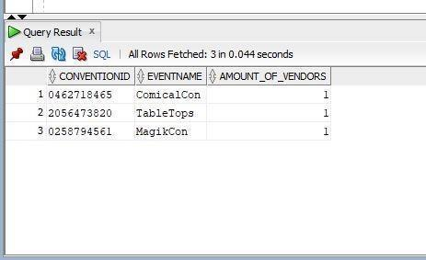

**Description:** This shows the event name and date for events that are after August 1st 2021. This would be important for LGS people to know their schedule for the fall/winter.

SELECT eventName, eventDate

FROM Convention

WHERE eventDate > '01-AUG-2021';

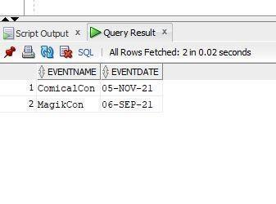

**Description:**  This shows the sales made at a store by which customers for a book alongside its price. Useful when looking for consumers who bought books and from what stores.

SELECT l.storeName AS Store_Hosting_Sale, c.firstName AS Customer_FirstName, c.lastName AS Customer_LastName, p.title AS Book_Title, p.price

FROM communityMember c JOIN sale s

ON c.memberID = s.consumer

JOIN product p

ON p.SKUNumber = s.product

JOIN lgs l

ON l.storeID = s.location

WHERE p.isBook = '1';

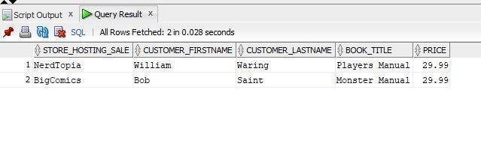

**Description:**  Good to use when searching for a production company’s contact information to sponsor a convention that is based on filming or Television.

SELECT companyName, emailAddress, phoneNumber

FROM SponsorshipCompany

WHERE companyName LIKE '%Productions';

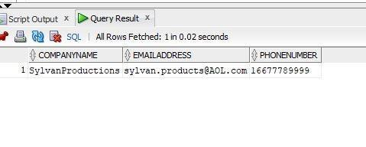

**Description:**  Good to use when a vendor no longer wants to participate in conventions in the

future.

DELETE FROM vendor

WHERE vendorName = 'NerdPoria';

